# **Analysis and Redesign of**

# **CEB Care Mobile Application**

Course: CO2214: Practical Work on CO2224

Group Number/Name: Group 08

Student IDs:

• EUSL/TC/IS/2021/COM/41

• EUSL/TC/IS/2021/COM/95

• EUSL/TC/IS/2021/COM/27

• EUSL/TC/IS/2021/COM/45

• EUSL/TC/IS/2021/COM/42

• EUSL/TC/IS/2021/COM/64

## 2

## 

## 1. Project Overview

**Project Title**: Analysis and Redesign of CEB Care Mobile Application

**Project Type**: Mobile Application

**Domain**: Utility Services

**Brief Description**: The CEB Care mobile application is designed to help users manage their electricity accounts, lodge complaints, report power outages, and track billing information. However, several usability and UX-related issues have been identified, hindering user experience and functionality.

The User: Residential and commercial electricity consumers who need to manage their accounts, report outages, and interact with CEB services.

## 2. Analyzing Questionnaires

## Forms response chart. Question title: 1. Have you used the CEB Care mobile app before?. Number of responses: 21 responses.

## Forms response chart. Question title: 2. How often do you use the app?. Number of responses: 21 responses.

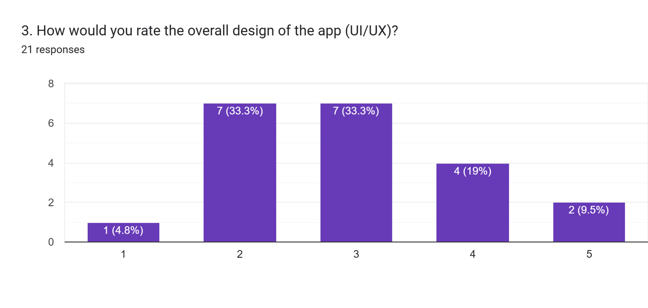

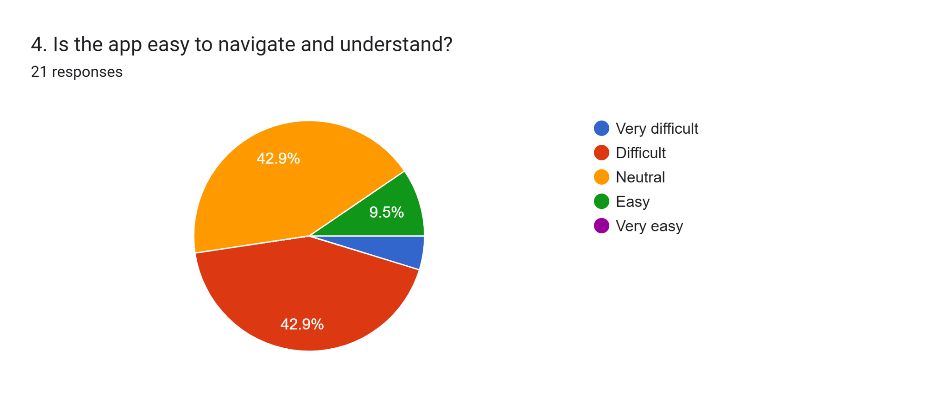

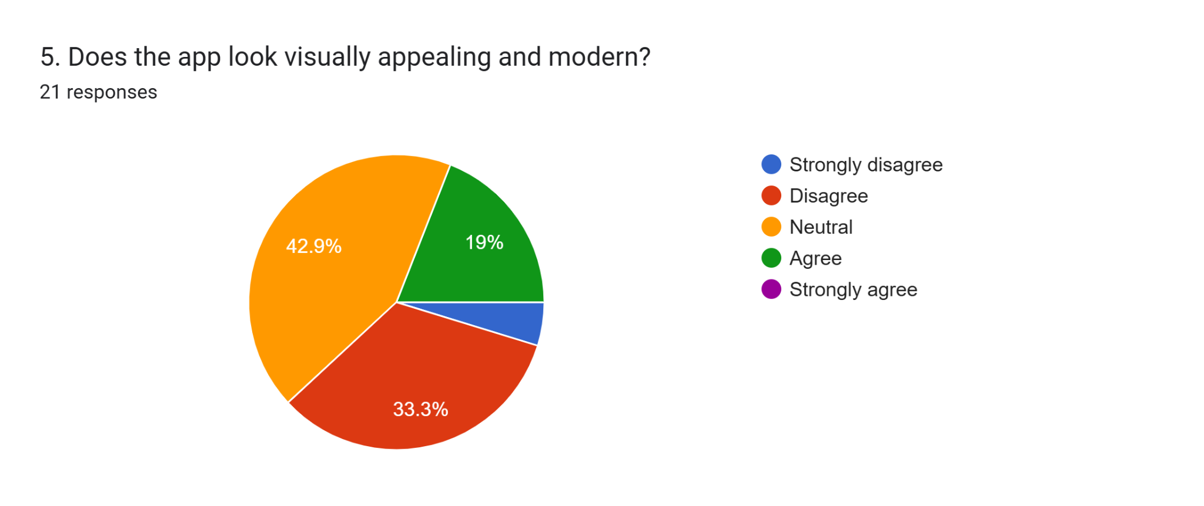

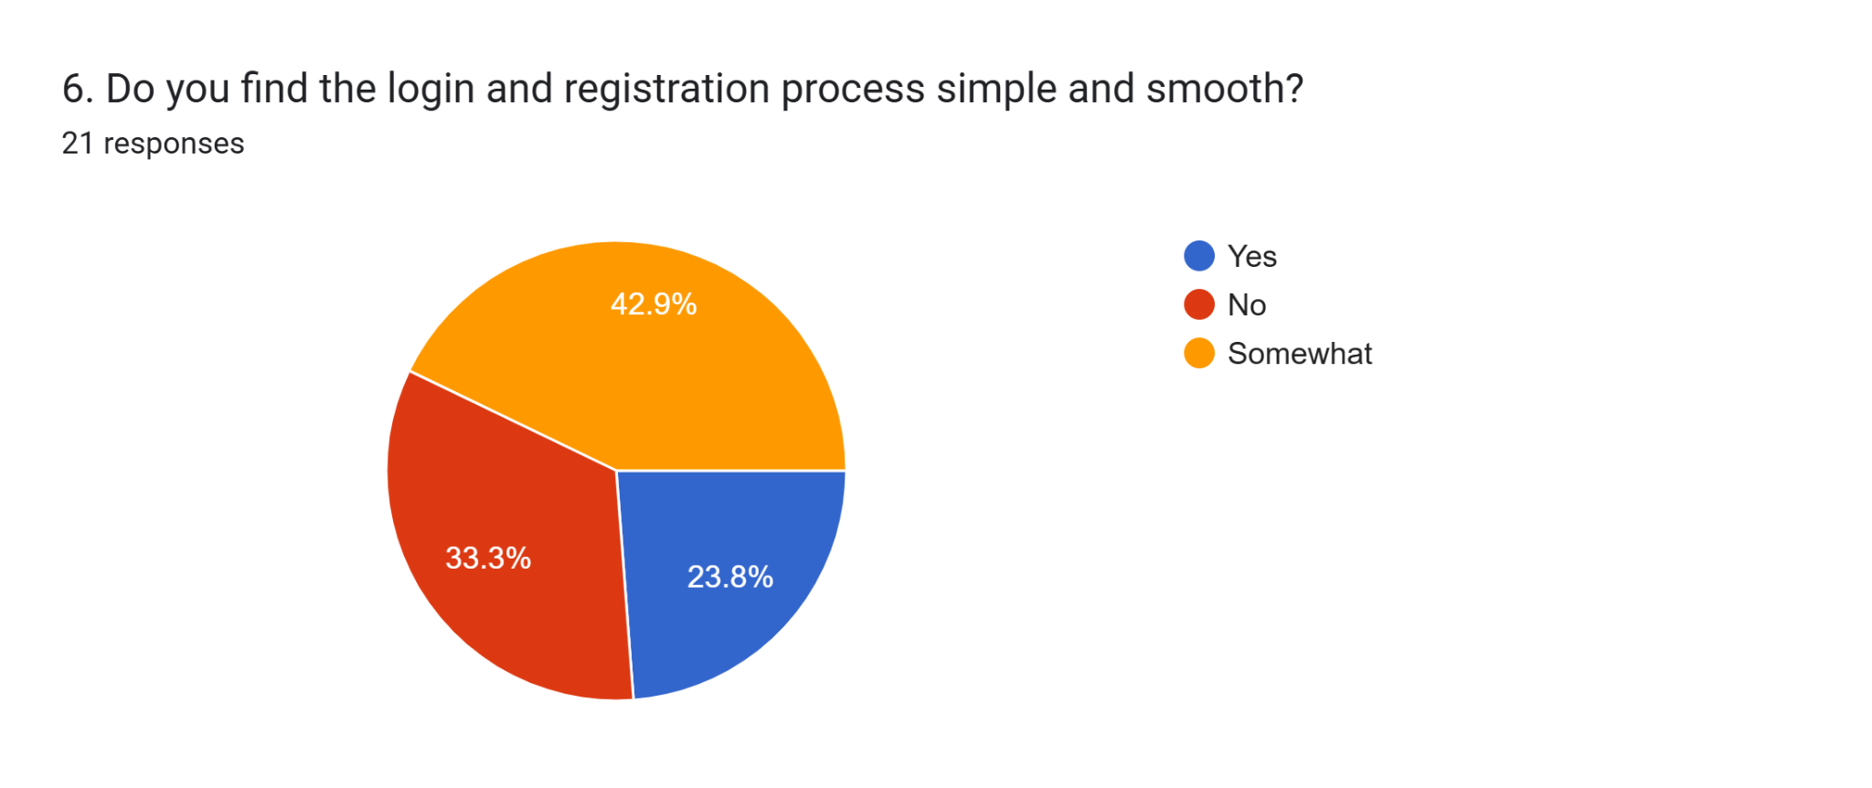

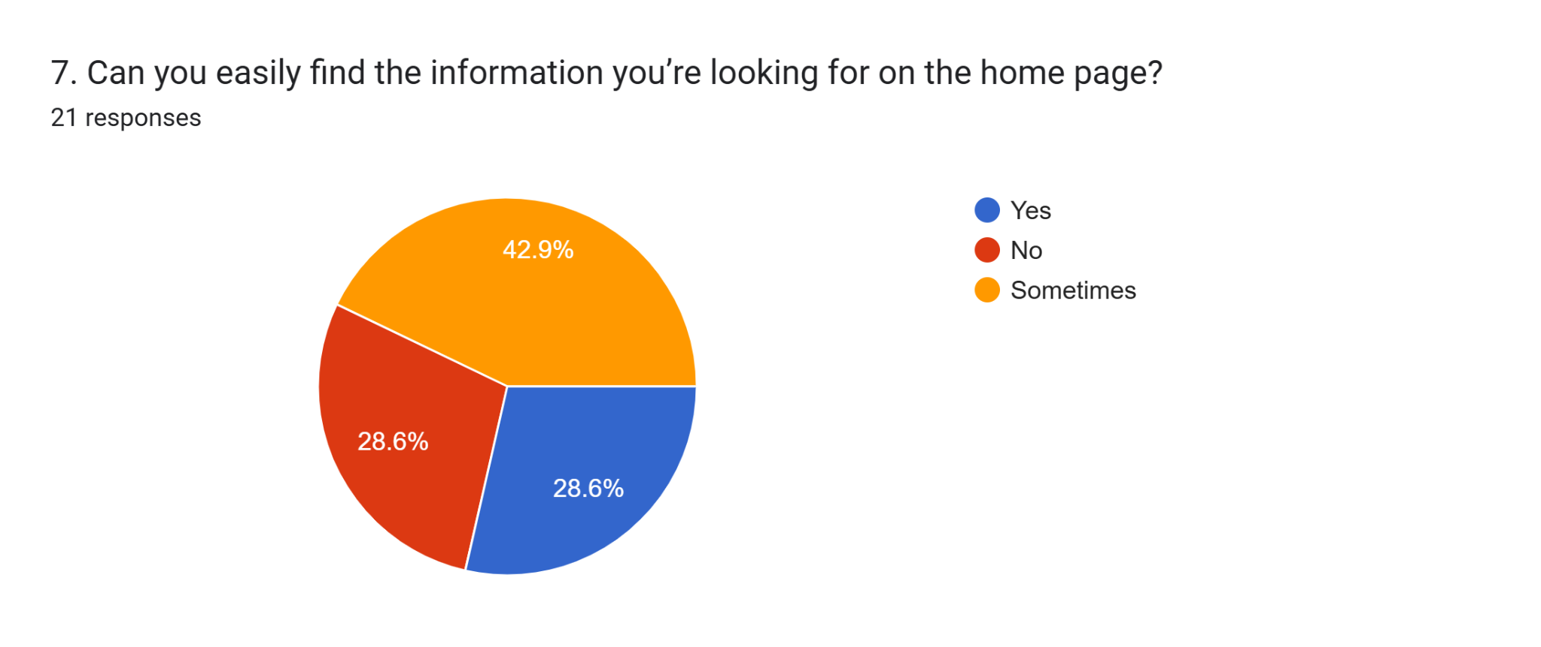

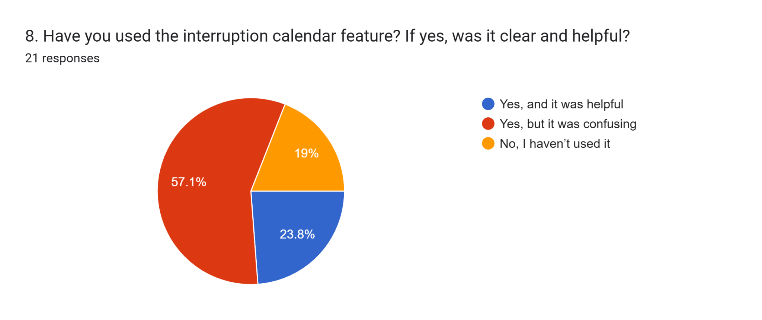

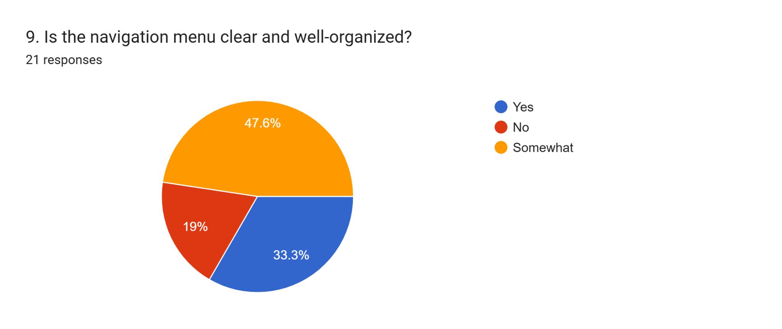

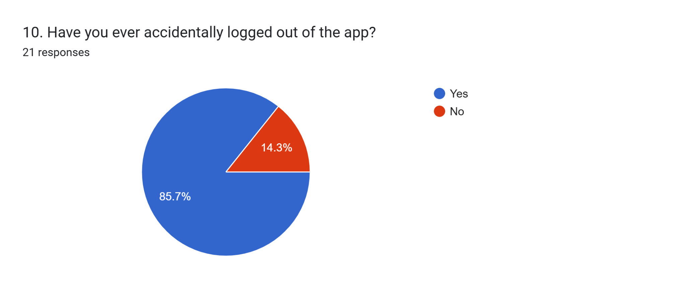

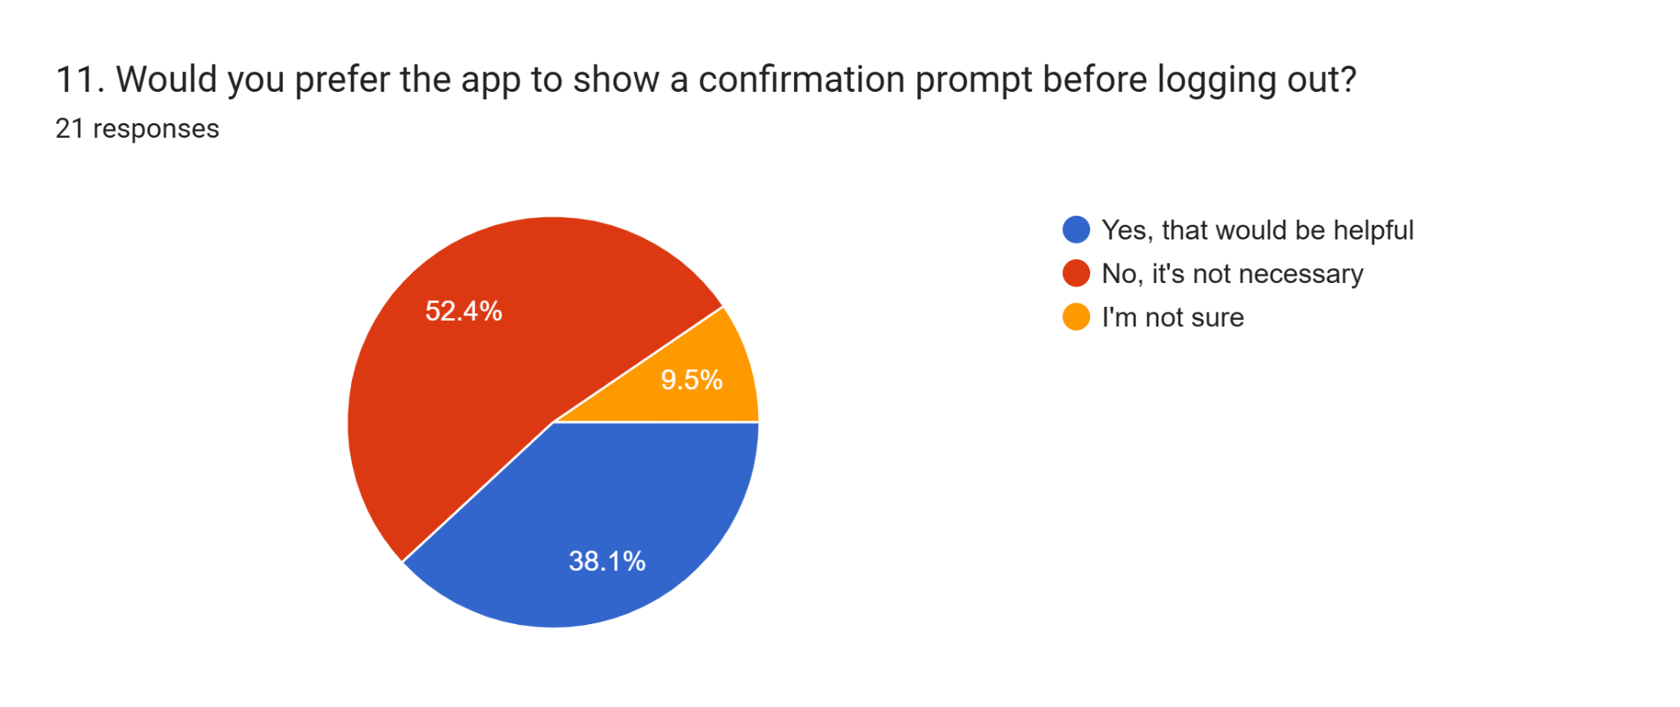

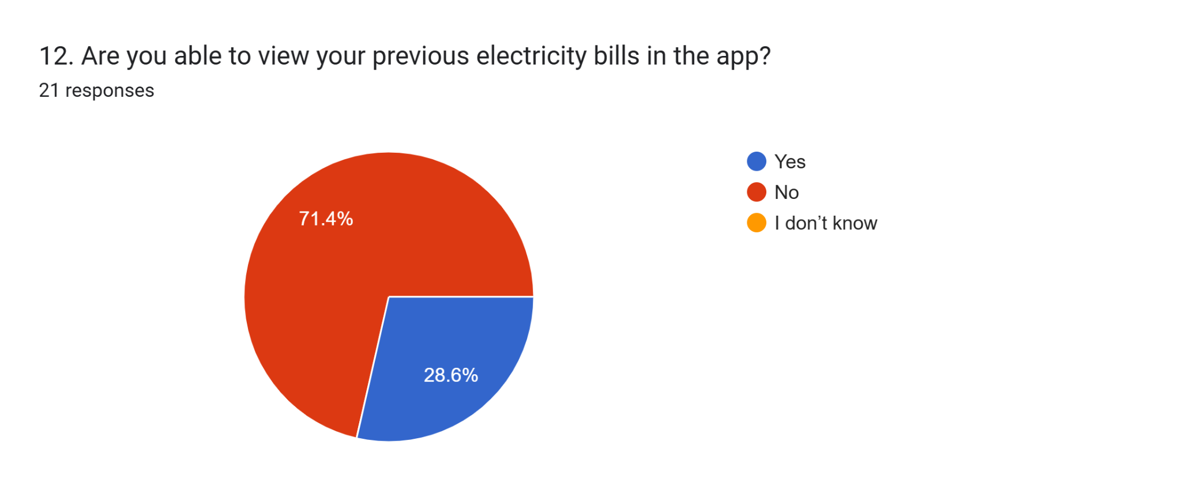

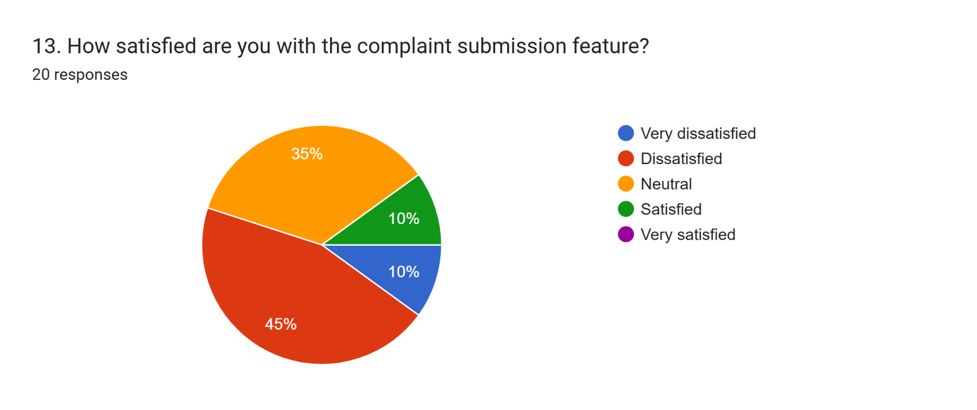

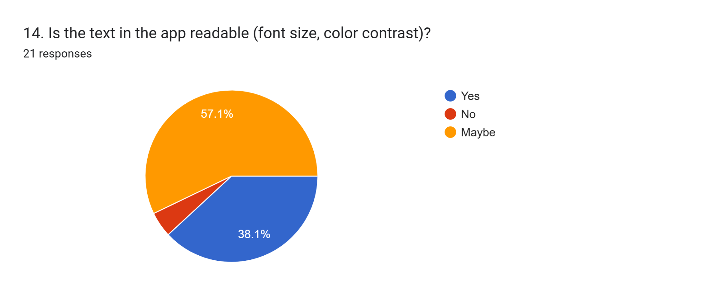

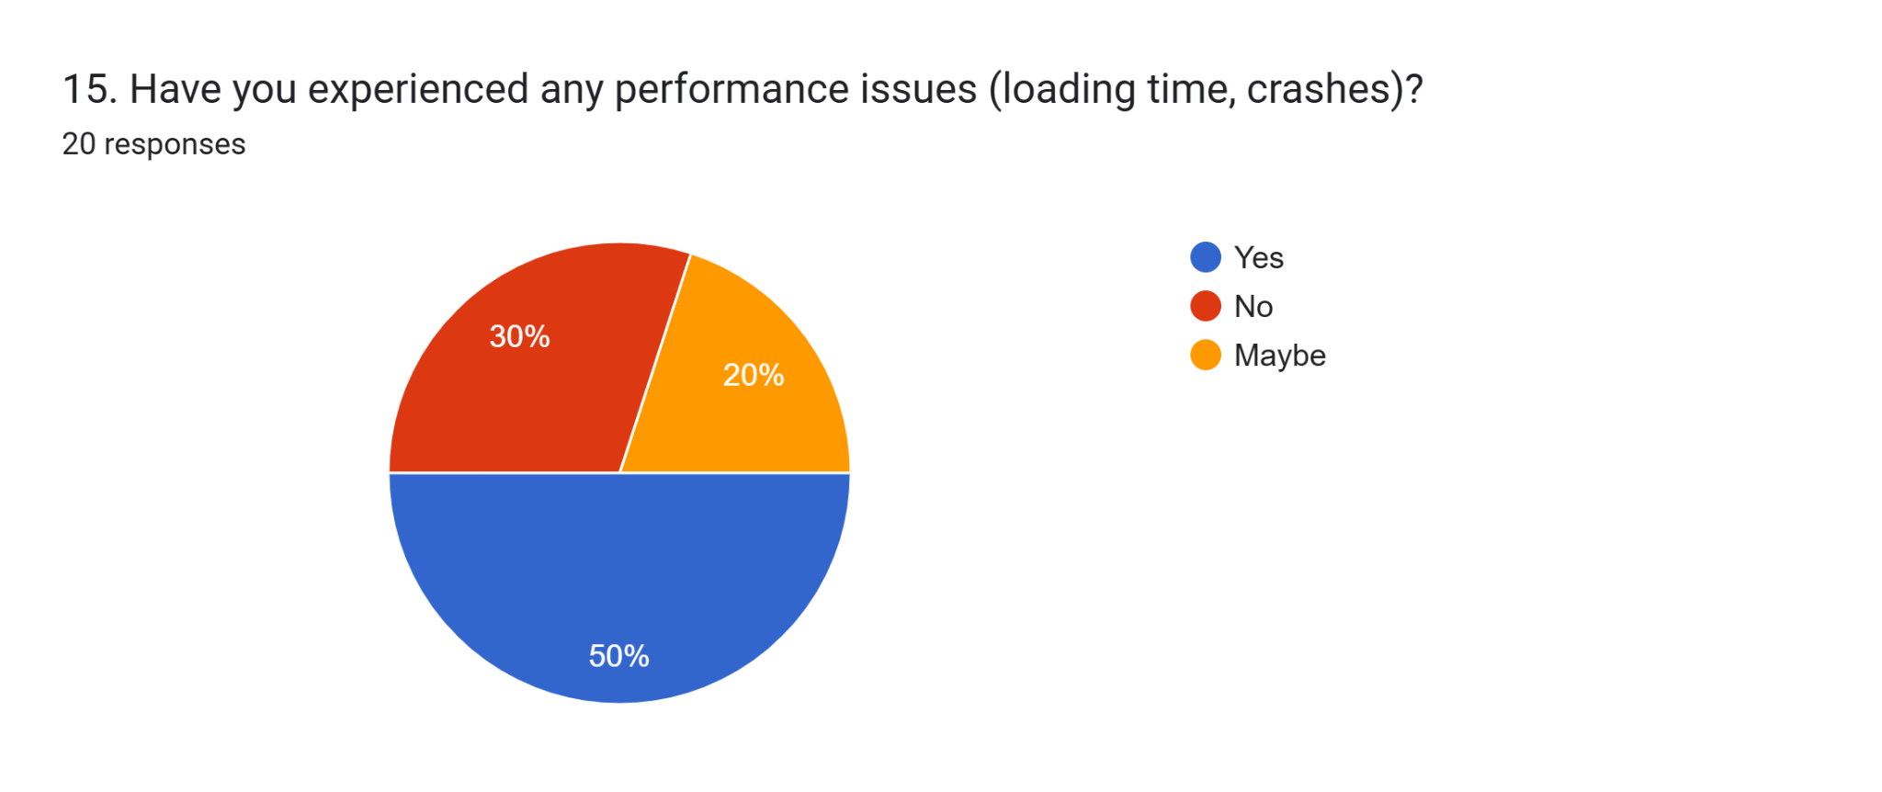

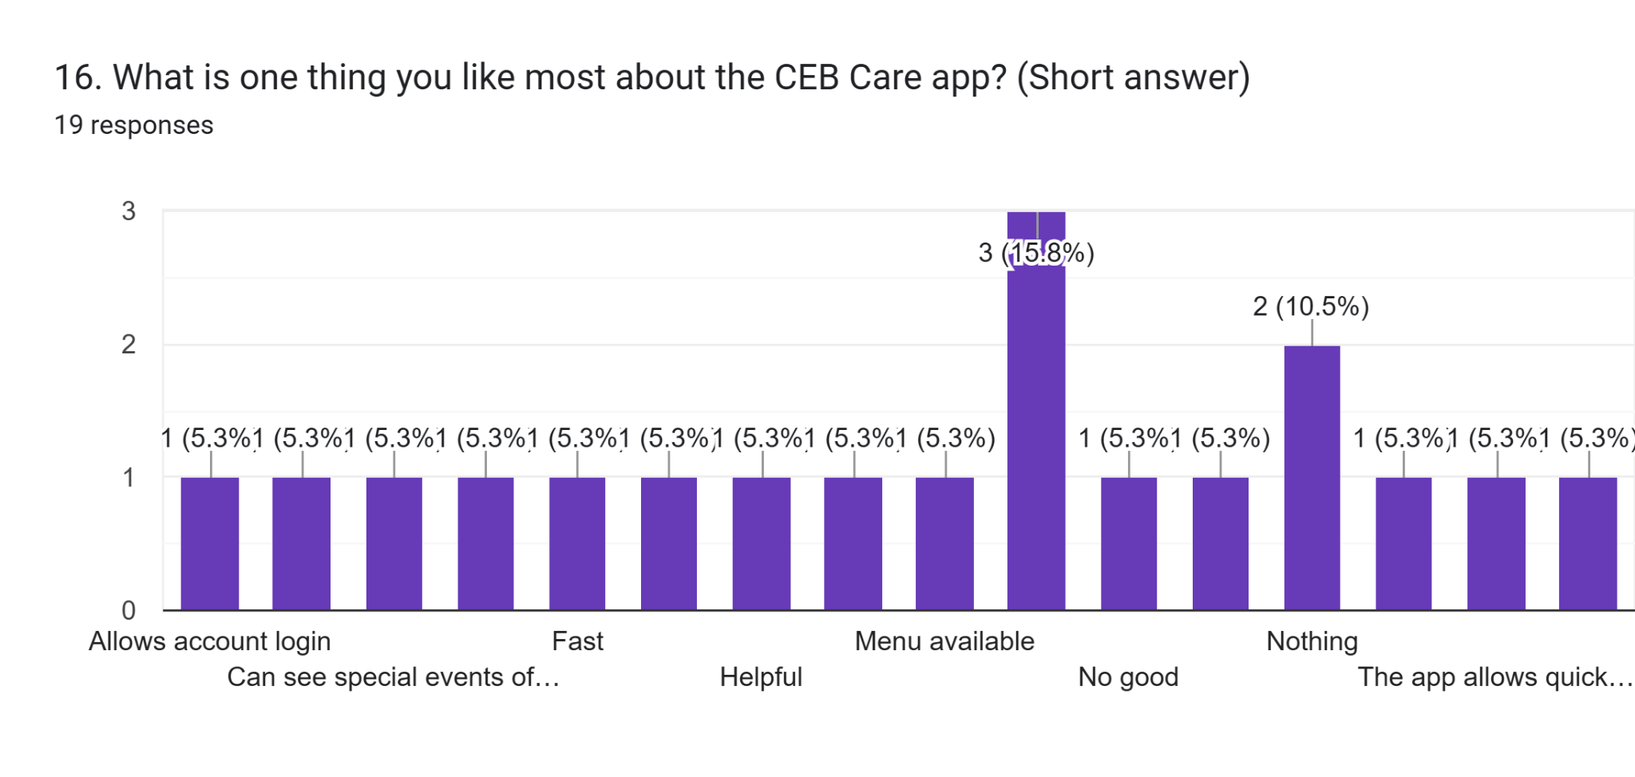

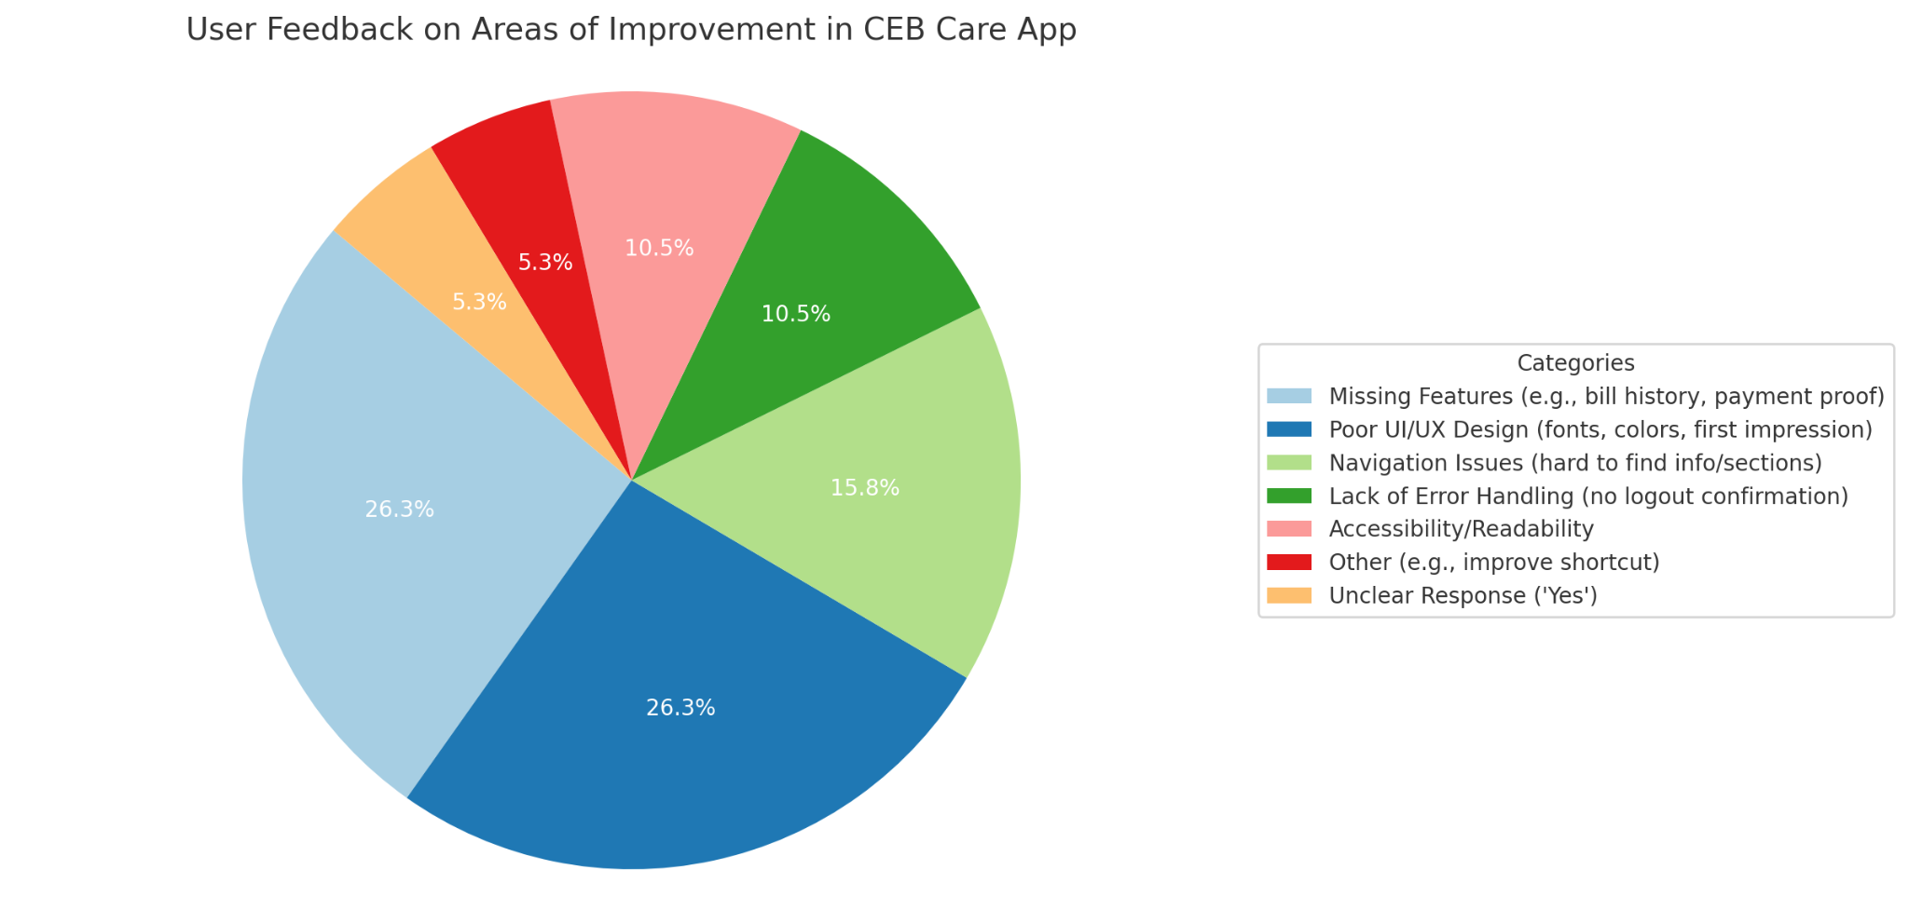

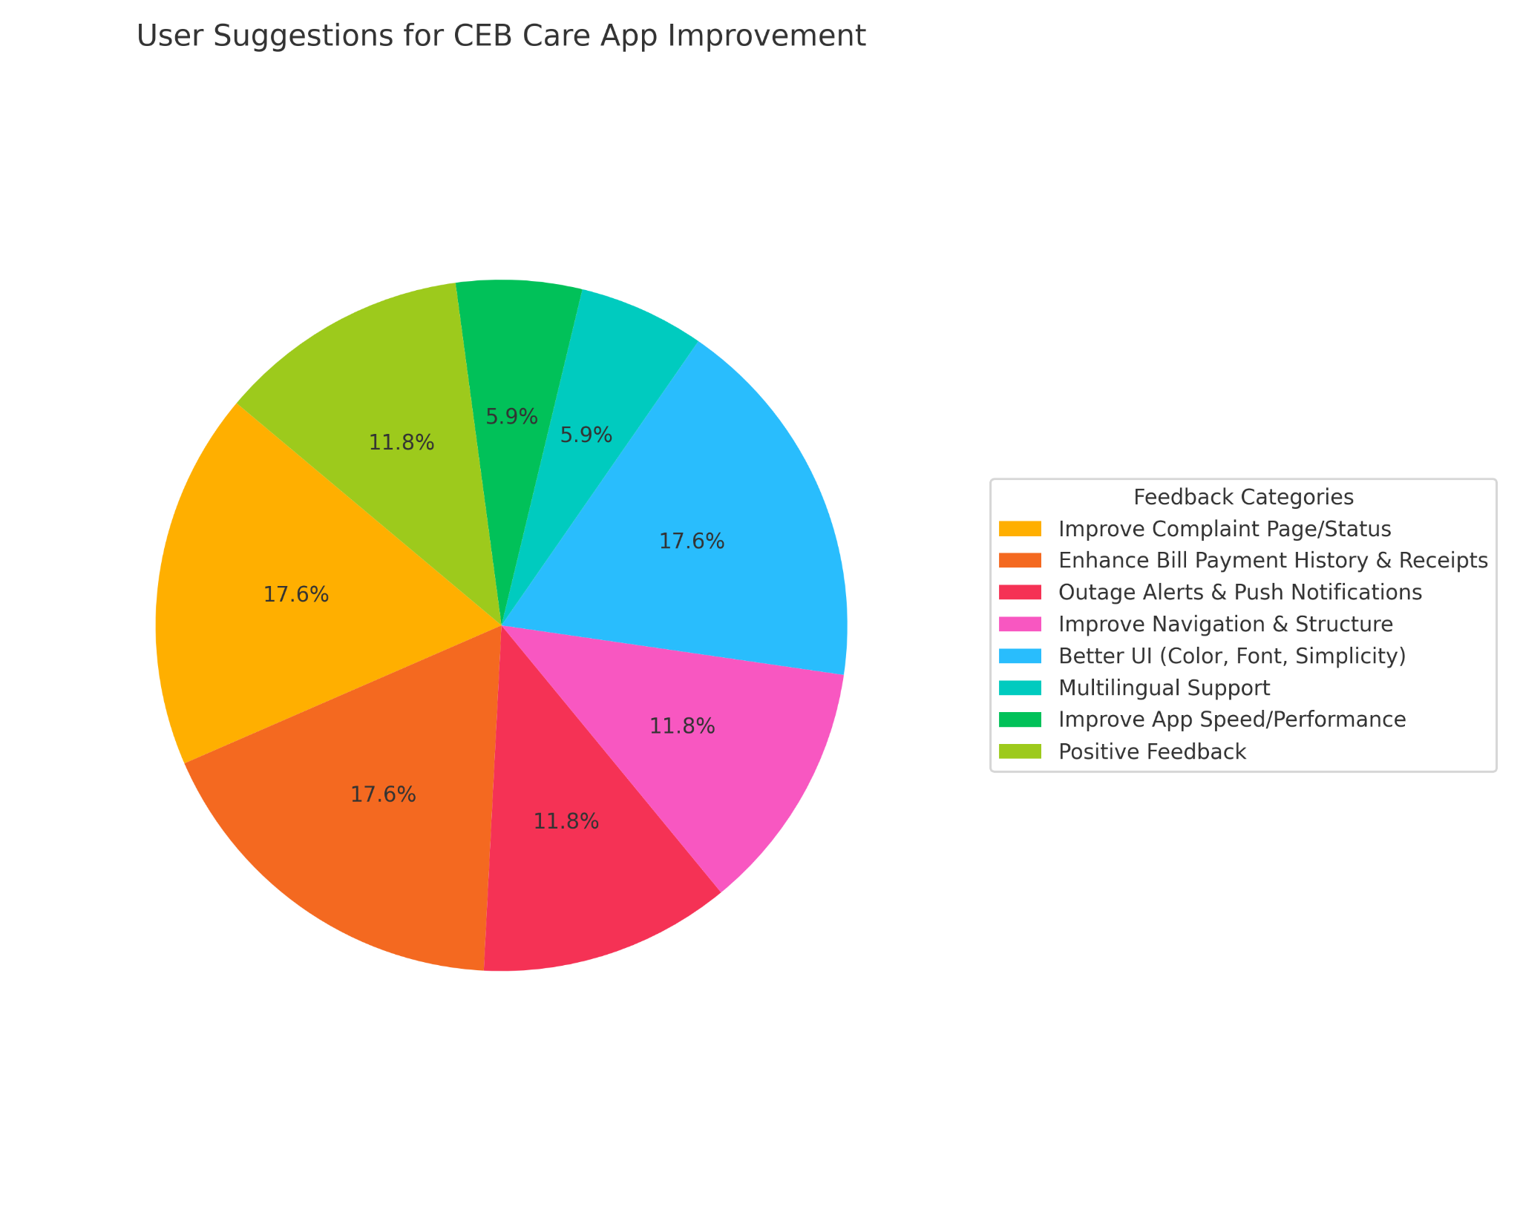

## 

## 3. Identifying Design Flaws & Gaps

Evaluation Criteria:

• Usability principles (e.g., learnability, efficiency, memorability, error prevention)

• Nielsen’s heuristics for usability evaluation

• WCAG accessibility guidelines

• HCI principles from Alan Dix’s book

### Usability Issues Identified:

#### Unattractive Login and Registration Screens

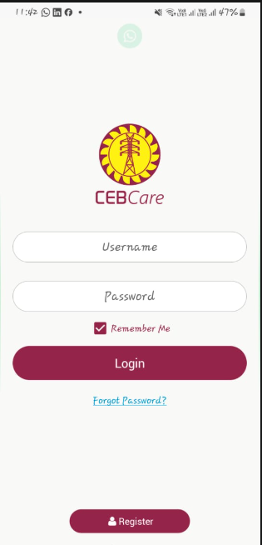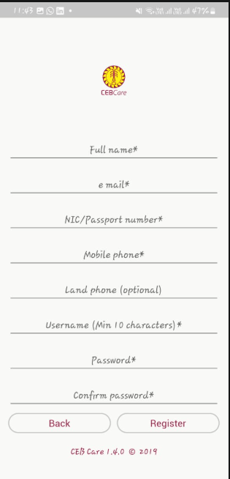

**4**

◦ **Issue**: Unattractive Login and Registration Screens

◦ **Heuristic Violation**: Aesthetic and minimalist design

◦ **Impact**: Users may find the app outdated and untrustworthy.

◦ **HCI Principle**: Engagement

◦ **WCAG Consideration**: Ensure color contrast, readable text, and intuitive form design.

◦ **Recommendation**: Redesign with a modern UI, improved typography, and clear call-to-action buttons.

#### Inefficient Home Page Design

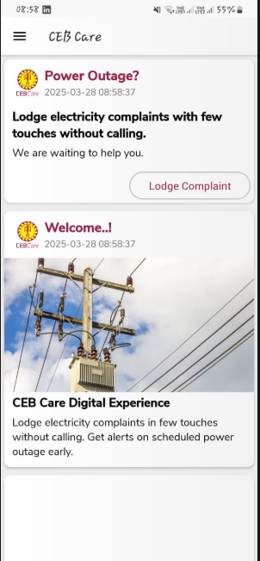

→ *screenshot of homepage*

**5**

◦ **Issue**: Inefficient Home Page Design

◦ **Heuristic Violation**: Recognition rather than recall

◦ **Impact**: Users struggle to navigate and find information quickly.

◦ **HCI Principle**: Task performance

◦ **WCAG Consideration**: Organize content in a structured and accessible manner.

◦ **Recommendation**: Introduce shortcut links for common actions and display key account details upfront.

#### Poorly Designed Interruption Calendar

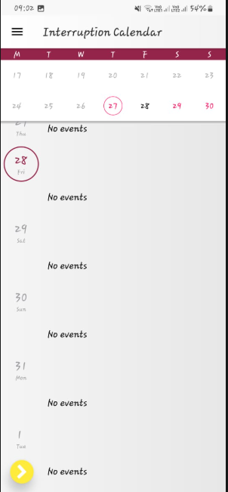

→ *screenshot of interruption calender*

**6**

◦ **Issue**: Poorly Designed Interruption Calendar

◦ **Heuristic Violation**: Visibility of system status

◦ **Impact**: Users struggle to understand scheduled interruptions.

◦ **HCI Principle**: Predictability

◦ **WCAG Consideration**: Improve readability and contrast for better accessibility.

◦ **Recommendation**: Enhance calendar UI with clear labels, color-coded status indicators, and improved layout.

#### Poor Navigation System

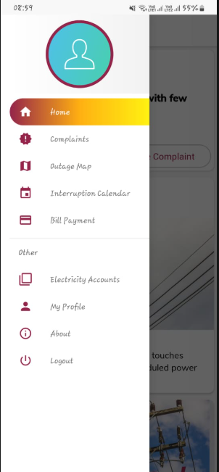

→ *screenshot of navigation menu*

**7**

◦ **Issue**: Poor Navigation System

◦ **Heuristic Violation**: User control and freedom

◦ **Impact**: Users struggle to move between sections efficiently.

◦ **HCI Principle**: Navigability

◦ **WCAG Consideration**: Implement accessible menus and proper focus states.

◦ **Recommendation**: Introduce a well-structured navigation menu and a dedicated notification panel.

#### Lack of Error Prevention on Logout



→ *gif image for logout function no error prevention*

**8**

◦ **Issue**: Lack of Error Prevention on Logout

◦ **Heuristic Violation**: Error prevention

◦ **Impact**: Users may lose progress or data due to accidental logouts.

◦ **HCI Principle**: Recoverability

◦ **WCAG Consideration**: Ensure that all interactions have confirmation steps.

◦ **Recommendation**: Add a confirmation dialog before logging out.

#### No Option to View Previous Electricity Bills



→ *screenshot for no option to view previous electricity bills*

**9**

◦ **Issue**: No Option to View Previous Electricity Bills

◦ **Heuristic Violation**: Consistency and standards

◦ **Impact**: Users face difficulties in tracking their electricity expenses.

◦ **HCI Principle**: Task efficiency

◦ **WCAG Consideration**: Ensure data is displayed in an accessible, structured format.

◦ **Recommendation**: Introduce a billing history section with downloadable statements.

#### Visually Unappealing Complaint Page

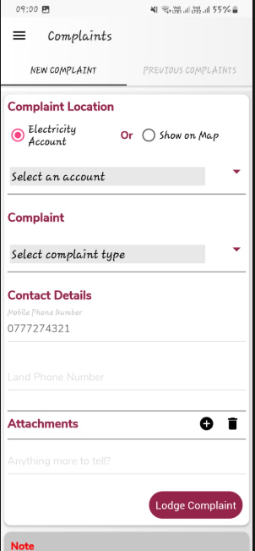

→ *screenshot of visually unappealing complaints page*

**10**

◦ **Issue**: Visually Unappealing Complaint Page

◦ **Heuristic Violation**: Aesthetic and minimalist design

◦ **Impact**: Users may find it difficult or frustrating to submit complaints.

◦ **HCI Principle**: Engagement

◦ **WCAG Consideration**: Ensure accessible form fields and instructions.

◦ **Recommendation**: Redesign the complaint form with better layout, visual cues, and a progress indicator.

### User Feedback:

Collected from users through surveys and interviews, confirming the above issues.

## 4*.HCI-Based Design Improvement Suggestions*

Proposed Improvements:

• Implement intuitive navigation and user-friendly layouts for enhanced learnability.

• Enhance error handling by providing clear and actionable messages that support error prevention and recovery.

• Improve real-time data synchronization for billing and account details to ensure efficiency and memorability.

• Optimize app performance and stability by refining background processes and minimizing system load.

• Enhance accessibility by following WCAG standards (e.g., proper color contrast, readable fonts, screen reader compatibility).

• Implement a simplified power outage reporting system with guided steps and emergency prioritization.

• Improve complaint tracking with a transparent status update system that provides user notifications and history logs.

By integrating usability principles, heuristic evaluation, WCAG guidelines, and HCI concepts, we ensure a more user-friendly, efficient, and accessible application experience for all users.

## *5. Redesigned Prototype in Figma*

## https://www.figma.com/design/CA7MoNBt7bnU0e5gBU1gOr/Group8?node-id=0-1&t=5NYuaa9e5qvvNNdu-1

## *6. Evaluation & Testing*

### Usability Testing Plan

The new design of the CEB Care mobile application will be evaluated through the following methods:

* **User Testing**: Real users representing both residential and commercial electricity consumers will perform key tasks (e.g., logging in, reporting outages, viewing bills). Observations will focus on task completion rates, time taken, and user errors.
* **Heuristic Evaluation**: A panel of usability experts will assess the redesigned prototype using Nielsen’s 10 usability heuristics to identify any remaining usability violations or inconsistencies.

**Expected Outcomes**

* **Higher Usability**: The modern interface, intuitive navigation, and better feedback mechanisms are expected to improve task success rates and reduce completion times.
* **Enhanced Accessibility**: With WCAG-compliant design elements (e.g., readable fonts, sufficient color contrast), the app will become more inclusive for all user groups.
* **Increased User Satisfaction**: Users are expected to report a more enjoyable and efficient experience, especially with the streamlined complaint process and access to billing history.
* **Fewer Errors**: Features like confirmation dialogs and clearer instructions will help reduce user mistakes, especially during critical actions like logout or complaint submission.

### Limitations & Future Improvements

* **Prototype Constraints**: The Figma prototype represents UI and interaction flow but lacks real backend integration, so real-time functionality and performance weren’t tested.
* **Small Testing Sample**: The user testing group was limited in size, which may not fully represent the diverse user base of CEB Care.
* **Future Improvements**:  
  + Add localization support for Sinhala and Tamil languages.
  + Integrate biometric login (e.g., fingerprint, face ID) for convenience.
  + Implement in-app live chat support for real-time customer assistance.
  + Conduct long-term field testing after deployment to capture usage data and further improve usability.

## 

## 

## *7. Conclusion*

The redesign of the CEB Care mobile application successfully addressed critical usability issues identified in the original version. Key improvements include a more intuitive navigation system, visually appealing interfaces, and enhanced accessibility features. These changes aim to provide users with a smoother, more efficient experience when managing their electricity accounts, reporting outages, and lodging complaints. The redesigned prototype demonstrates that applying structured UX principles leads to a more user-centered and functional application.

**HCI Theory Helped**

We also incorporated Nielsen’s heuristics (e.g., visibility of system status, aesthetic design) and WCAG guidelines to improve both usability and accessibility.

**Lessons Learned**

* User feedback is essential: Direct input from users revealed usability flaws that may not have been obvious during initial reviews.
* Design is iterative: Creating a good user experience requires continuous testing, feedback, and refinement.
* Theory supports practice: HCI concepts are not just academic—they provide a strong foundation for solving real design problems

***8. References***.

**https://cebcare.ceb.lk/Identity/Account/Login?ReturnUrl=%2F**